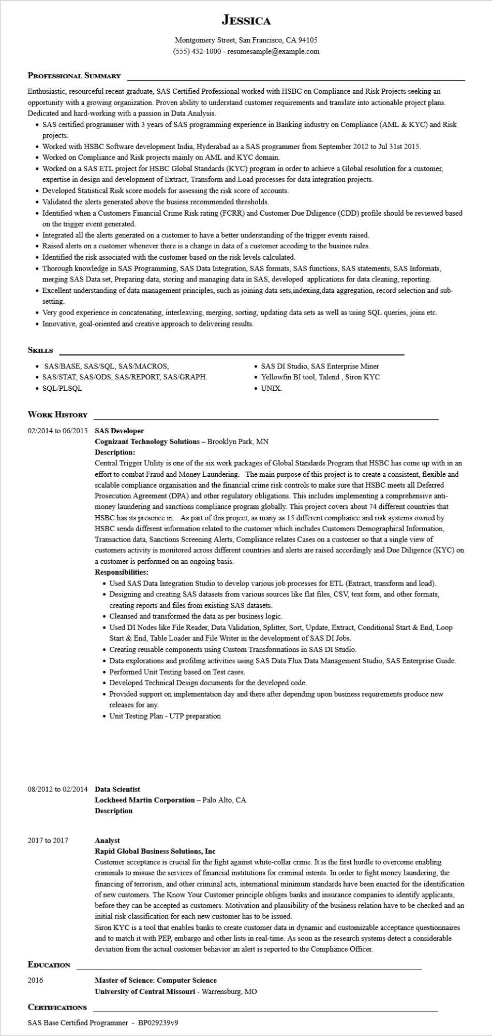
JESSICA
Montgomery Street, San Francisco, CA 94105
(555) 432-1000 - resumesample@example.com
PROFESSIONAL SUMMARY
Enthusiastic, resourceful recent graduate, SAS Certified Professional worked with HSBC on Compliance and Risk Projects seeking an opportunity with a growing organization. Proven ability to understand customer requirements and translate into actionable project plans. Dedicated and hard-working with a passion in Data Analysis.
• SAS certified programmer with 3 years of SAS programming experience in Banking industry on Compliance (AML & KYC) and Risk projects.
• Worked with HSBC Software development India, Hyderabad as a SAS programmer from September 2012 to Jul 31st 2015.
• Worked on Compliance and Risk projects mainly on AML and KYC domain.
• Worked on a SAS ETL project for HSBC Global Standards (KYC) program in order to achieve a Global resolution for a customer, expertise in design and development of Extract, Transform and Load processes for data integration projects.
• Developed Statistical Risk score models for assessing the risk score of accounts.
• Validated the alerts generated above the busiess recommended thresholds.
• Identified when a Customers Financial Crime Risk rating (FCRR) and Customer Due Diligence (CDD) profile should be reviewed based on the trigger event generated.
• Integrated all the alerts generated on a customer to have a better understanding of the trigger events raised.
Raised alerts on a customer whenever there is a change in data of a customer accoding to the busines rules.
• Identified the risk associated with the customer based on the risk levels calculated.
• Thorough knowledge in SAS Programming, SAS Data Integration, SAS formats, SAS functions, SAS statements, SAS Informats, merging SAS Data set, Preparing data, storing and managing data in SAS, developed applications for data cleaning, reporting.
• Excellent understanding of data management principles, such as joining data sets, indexing,data aggregation, record selection and sub- setting.
• Very good experience in concatenating, interleaving, merging, sorting, updating data sets as well as using SQL queries, joins etc. • Innovative, goal-oriented and creative approach to delivering results.
SKILLS
• SAS/BASE, SAS/SQL, SAS/MACROS,
• SAS DI Studio, SAS Enterprise Miner
• SAS/STAT, SAS/ODS, SAS/REPORT, SAS/GRAPH. • SQL/PLSQL
• Yellowfin BI tool, Talend, Siron KYC • UNIX.
WORK HISTORY
02/2014 to 06/2015 SAS Developer
Cognizant Technology Solutions - Brooklyn Park, MN Description:
Central Trigger Utility is one of the six work packages of Global Standards Program that HSBC has come up with in an effort to combat Fraud and Money Laundering. The main purpose of this project is to create a consistent, flexible and scalable compliance organisation and the financial crime risk controls to make sure that HSBC meets all Deferred Prosecution Agreement (DPA) and other regulatory obligations. This includes implementing a comprehensive anti- money laundering and sanctions compliance program globally. This project covers about 74 different countries that HSBC has its presence in. As part of this project, as many as 15 different compliance and risk systems owned by HSBC sends different information related to the customer which includes Customers Demographical Information, Transaction data, Sanctions Screening Alerts, Compliance relates Cases on a customer so that a single view of customers activity is monitored across different countries and alerts are raised accordingly and Due Diligence (KYC) on a customer is performed on an ongoing basis.
Responsibilities:
• Used SAS Data Integration Studio to develop various job processes for ETL (Extract, transform and load).
• Designing and creating SAS datasets from various sources like flat files, CSV, text form, and other formats, creating reports and files from existing SAS datasets.
• Cleansed and transformed the data as per business logic.
• Used DI Nodes like File Reader, Data Validation, Splitter, Sort, Update, Extract, Conditional Start & End, Loop Start & End, Table Loader and File Writer in the development of SAS DI Jobs.
• Creating reusable components using Custom Transformations in SAS DI Studio.
• Data explorations and profiling activities using SAS Data Flux Data Management Studio, SAS Enterprise Guide.
• Performed Unit Testing based on Test cases.
• Developed Technical Design documents for the developed code.
• Provided support on implementation day and there after depending upon business requirements produce new releases for any.
• Unit Testing Plan - UTP preparation
08/2012 to 02/2014 Data Scientist
Lockheed Martin Corporation - Palo Alto, CA Description
2017 to 2017
EDUCATION
2016
CERTIFICATIONS
Analyst
Rapid Global Business Solutions, Inc
Customer acceptance is crucial for the fight against white-collar crime. It is the first hurdle to overcome enabling criminals to misuse the services of financial institutions for criminal intents. In order to fight money laundering, the financing of terrorism, and other criminal acts, international minimum standards have been enacted for the identification of new customers. The Know Your Customer principle obliges banks and insurance companies to identify applicants, before they can be accepted as customers. Motivation and plausibility of the business relation have to be checked and an initial risk classification for each new customer has to be issued.
Siron KYC is a tool that enables banks to create customer data in dynamic and customizable acceptance questionnaires and to match it with PEP, embargo and other lists in real-time. As soon as the research systems detect a considerable deviation from the actual customer behavior an alert is reported to the Compliance Officer.
Master of Science: Computer Science
University of Central Missouri - Warrensburg, MO
SAS Base Certified Programmer - BP029239v9

